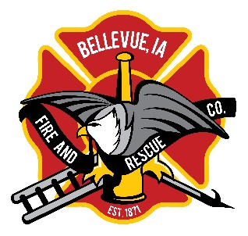


106 N. 3rd St.
Bellevue, IA 52031
Kent Clasen
Fire Chief 563-599-6984
Kent.clasen@bellevueia.gov

Operation E.D.I.T.H.
Exit Drill In The Home
Sunday October 13, 2024 6:00 P.M.

On Sunday October 13th at 6:00 the town fire siren will sound. Families are asked to exit their home following the pre-plan that they have discussed with their families and meet at their special meeting place.
Fire Trucks will be driving by counting participants and handing out Fire Prevention Material.
Please wait for a truck to pass your residence.
Thanks, and be fire safe!

